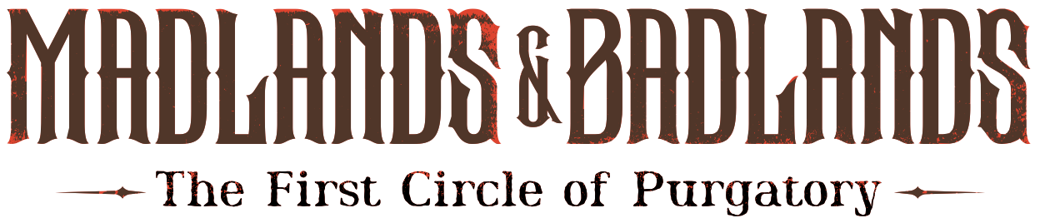
PRESS RELEASE
Award-Winning Horror Western “A Town Called Purgatory” Becomes an Audio Drama
ZealZaddy announces “Madlands & Badlands”; Kickstarter and pilot episode arrive Nov. 13
MIAMI (Sept. 30, 2026) — The haunted frontier of the award-winning Weird Western horror film, A Town Called Purgatory is expanding into audio. South Florida-based publisher ZealZaddy has licensed the film to create Madlands & Badlands: The First Circle of Purgatory, an original scripted horror anthology podcast set in the same universe. Season 1 will run 10 episodes, with an original score and a professional voice cast, and will release in 2027.
The series is written by ZealZaddy executive editor and principal Cliff Dunn, working with the film’s creators, producers, and stars, Ken Arnold and Dan DeLuca. It is not a retelling of the film. Each episode is a new story with new characters, set across the same haunted Old West: gunslingers, prospectors and drifters who find the frontier is hiding far more than they bargained for. “Audio lets us take listeners places the camera couldn’t: further out into the dust, and deeper into the dark,” said Scott Coventry, co-founder and creative director of ZealZaddy.
Fans can meet Arnold and DeLuca in Orlando, Florida at Spooky Empire, one of the country's leading horror conventions, Oct. 30–Nov. 1, 2026. On Halloween, Saturday, Oct. 31, the team will screen A Town Called Purgatory in the Filmmakers Lounge from 2 to 4 p.m. and take questions afterward. The screening is free with convention admission. Fans can also stop by the ZealZaddy booth and read a scene from Madlands & Badlands: The First Circle of Purgatory with Arnold and DeLuca for an opportunity to be cast in a role in a future episode.
"We imagined Purgatory from the ground up,” said Ken Arnold, who developed the film’s original story with Dan DeLuca and stars in it. “Watching it grow into a full series, with new characters and new dilemmas, has been an amazing ride.”
ZealZaddy will fund the series on Kickstarter. The campaign opens Friday, Nov. 13, with a sample episode so listeners can hear what they are backing, along with stretch goals that could expand Season 1 to 20 or 30 episodes.
“These are the stories a single movie never has room for,” said Dan DeLuca, who developed the original story with Arnold, wrote the screenplay, and stars opposite him.
Fans can follow the campaign now at: https://www.kickstarter.com/projects/zealzaddy/madlands-and-badlands?ref=6zc9jp
A Town Called Purgatory (2024), directed by Matt Servitto and written by Arnold and DeLuca, follows a Civil War era Yankee lawman and an ex-Confederate who chase a gang of train robbers into a ghost town — and find something terrifying waiting for them. The film won Best in Show at the Sci-Fi Horror & Action Film Festival, Best Feature at Creature Feature Weekend and the Tombstone Film Festival, and top horror honors at the Garden State Film Festival and FirstGlance Philadelphia. It is streaming on Amazon Prime Video and Tubi.
About ZealZaddy - https://zealzaddy.com/
ZealZaddy is an award-winning storytelling studio focused on tabletop roleplaying games and streaming and podcast entertainment. Founded with a mission to elevate narrative play, ZealZaddy publishes a growing library of titles on DriveThruRPG and itch.io, streams weekly actual plays, and produces two original shows: the creator-focused talk show StoryTalk and the competitive game show PaperBag: The Roleplaying Game Show (the latter benefitting charity). In 2025, ZealZaddy successfully launched its first crowdfunding project, with more in development. ZealZaddy continues expanding its catalogue and live programming with a focus on original, human-made storytelling. Learn more at zealzaddy.com. In September 2026, ZealZaddy won the 2026 Crit Award for Best Multiplayer Tabletop Roleplaying Game for producing A Midwinter’s Terror, a holiday horror roleplaying adventure for Monte Cook Games’ Cypher System.
Media contact: Jeanmarie Ferrara, Ferrara Strategic Communications · 305-458-3778 · jferrara@ferrarasc.com
###

